Prolific Opening Guide
Step 1. Visit the prolific on https://www.prolific.com/
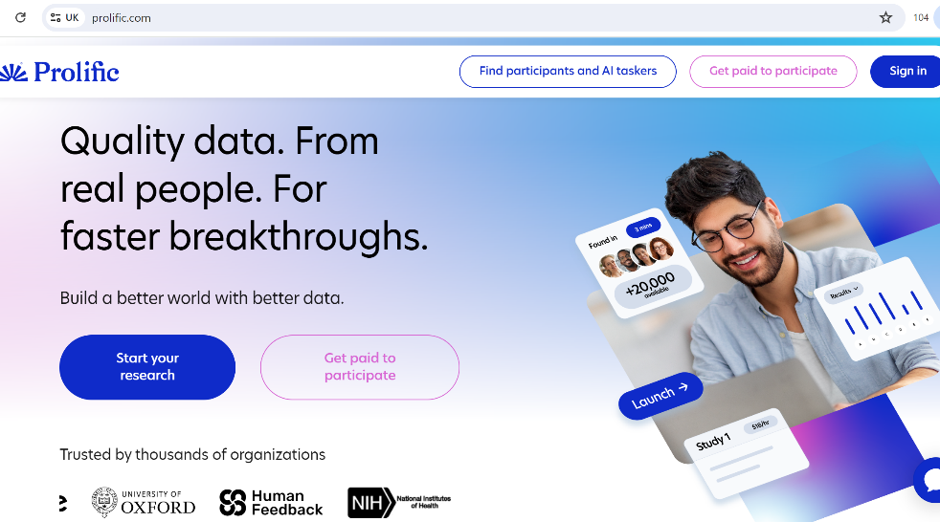
Step 2. Click on ‘Get Paid to Participate’ https://www.prolific.com/participants
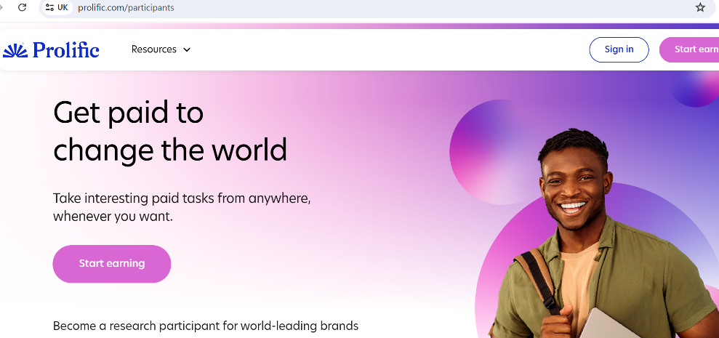
Step 3. Click on ‘Start earning’
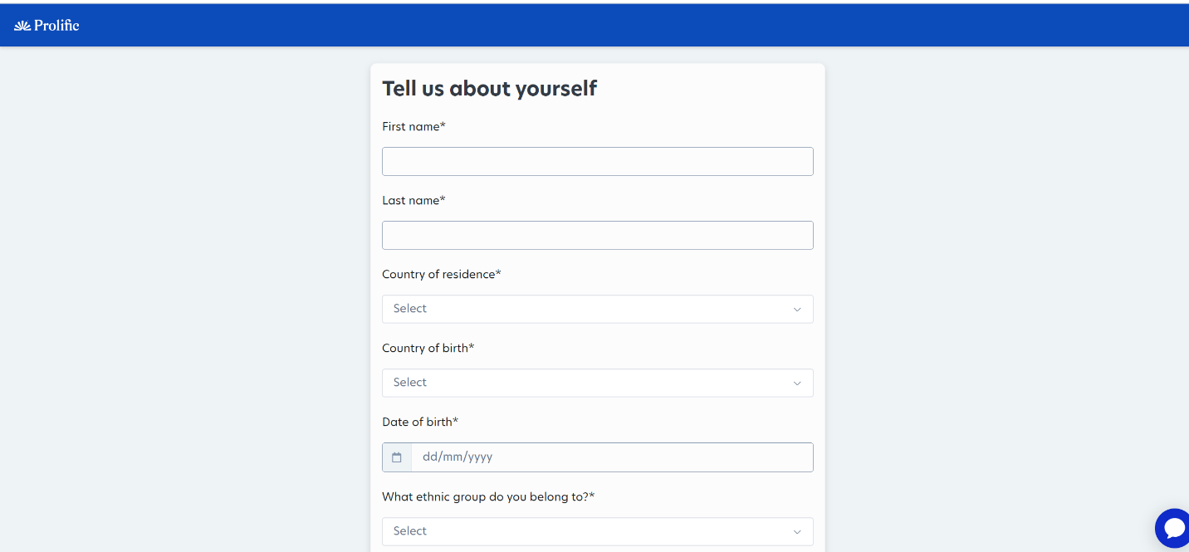
Step 4. Complete registration.
Below are answers to the Test Questions
- In
- Often
- It’s a hat
- Rewrite
- It is raw
- Large
- It’s a ball
Question 8 is as below. We can draft the answers for the question if the client is unable.
Ok, now for a creative writing exercise! Pick two of these zany superheroes and use your imagination to write a sentence or two of backstory or description for both of them. Be wild! Be weird! Be wonderful🌤️ (Be sure to include the names of the superheroes you pick!) Betty Boom / Scarlet Fever / Terrible Trio / Dr. Hexagon / Captain Incognito.

